**Title:** Lab 1: Observation, Modeling, and Communication

**Name:** Robert Bara **Partner:** Lilly Veloso

**General Objective:** The purpose of this lab is to explore RLC circuits, that is, circuits consisting of a resistor (R), inductor (L), and capacitor (C) wired in series. The RLC circuit will contain its own resonant frequency at which the circuit will behave based upon it. RLC circuits are oscillators and this lab will model an RLC circuit in Multisim, calculate the circuit’s resonant frequency, and examine the behavior of the circuit by observing the circuit’s frequency response and using an oscilloscope.

1. **Background Activities:** RLC circuits consist of three components besides the source and ground, the resistor (R), inductor (L), and capacitor (C). LC circuits produces a harmonic oscillator when current flows through the circuit. The oscillating signal is caused when energy is shifted between the electrostatic field of a capacitor and magnetic field of an inductor, thus creating a periodic AC signal from a DC power input. By adding the resistor, the RLC circuit is oscillations can be controlled (damped) by the resistor (or potentiometer). RLC circuits are commonly created as filters and may attenuate signals of a specific bandwidth, depending on their cutoff frequencies. An RLC bandpass filter is commonly used to filter modulation within radios, televisions, or within audio circuits such as speakers. They also can act to discharge circuits or act as a voltage multiplier when in series, or a current multiplier in parallel.

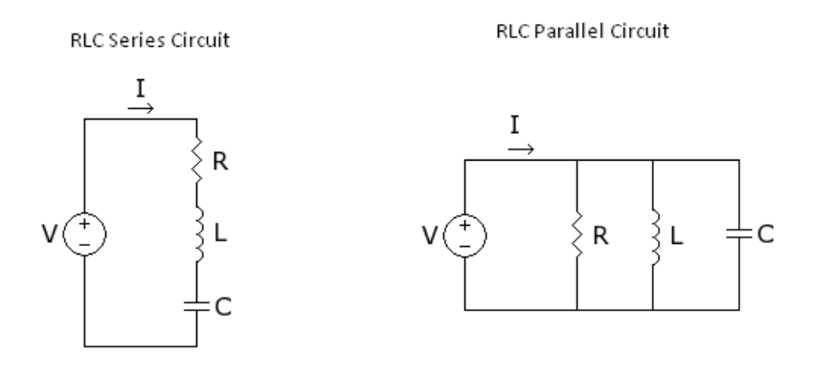

Figure 1. Example of an RLC Circuit in Series or Parallel. From Lab Manual

At the resonant frequency, the frequency minimizes impedance in a series wiring. In parallel, the impedance is maximized. To calculate the resonant frequency in Hz, the equation below may be used:

$$f_{0}=\frac{1}{2π\sqrt{LC}}$$

1. **Procedure:** To examine the behavior of an RLC series circuit, Multisim will be used to model the circuit. The initial voltage source will be a clock voltage source (or you could use Multisim’s frequency generator as a source and set it to clock mode). The settings for the clock is given by entering the calculated resonant frequency in Hz, an amplitude of 1 Vpp, and a DC Offset of 0V. The components used in the circuit have the following values: L=22mH, R=10Ω, C=47uF. With this information, the resonant frequency can be calculated using equation 1 as follows:

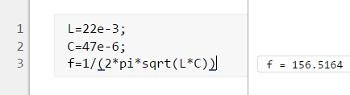

Figure 2. MATLAB Calculation of Resonant Frequency

An RLC series circuit should then be built in multisim similar to the setup in Figure 1. Multisim’s oscilloscope can be added to compare the input and output signals as shown below:

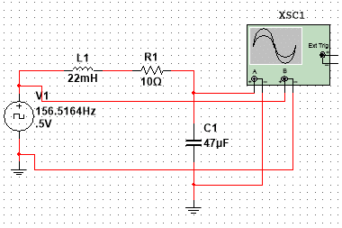

Figure 3. RLC series circuit with resonant frequency

Running the circuit and double clicking on the oscilloscope will then allow scaling and for the pattern of attenuation to be observed. Hit stop to stop running the circuit and screenshot the results. Repeat the procedure two more times by altering the frequency above and below the resonant frequency. Record how the circuit behaves differently based on the frequency.

Next, we will observe the frequency response of the RLC circuit. The oscilloscope should be removed, and the voltage source should be changed from the clock source to an AC Voltage Source with standard 1Vpk and 1kHz. A differential voltage probe should be attached across the capacitor:

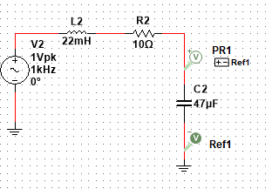

Figure 4. RLC series circuit with Voltage Probe

An AC Sweep will be ran with the following settings:

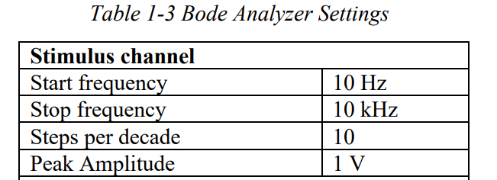

Using the cursors, right click and select the next Ymax to observe the simulated resonant frequency. Record the frequency in Hz and compare it to the calculated value.

1. **Results:**
   1. **Simulation Results:**

The following section contains results generated in Multisim.

Attenuation Behavior:



Figure 5. RLC circuit with calculated resonant frequency

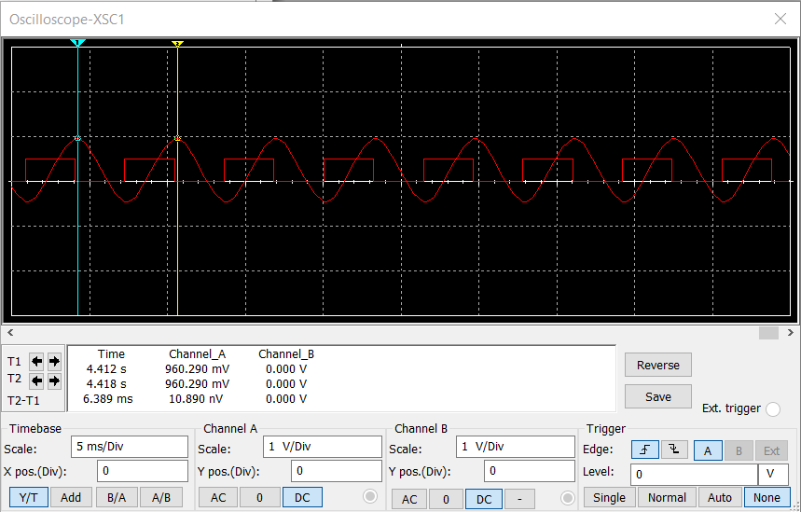

Figure 6. Oscilloscope reading of Figure 5's circuit

The circuit and response shown above is when the resonant frequency was selected to be the input frequency to the circuit. The output is an amplified sinusoid wave that oscillated the inputted clock wave.

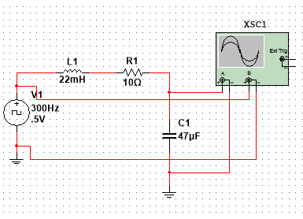

Figure 7 RLC circuit above resonant frequency. F0=300Hz

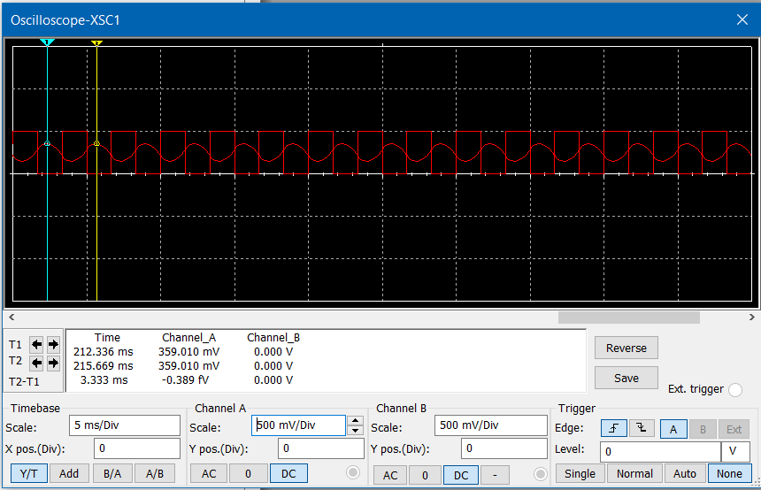

Figure 8. Oscilloscope reading of Figure 7's circuit

Compared to the first circuit, when changing the input frequency to be above the resonant frequency, at f=300Hz, the signal oscillates much faster than the previous circuit, yet the amplitude decreases.

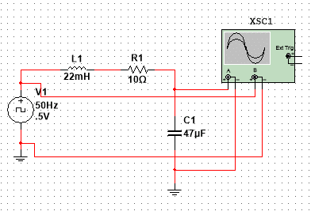

Figure 9. RLC circuit below resonant frequency. F0=50Hz

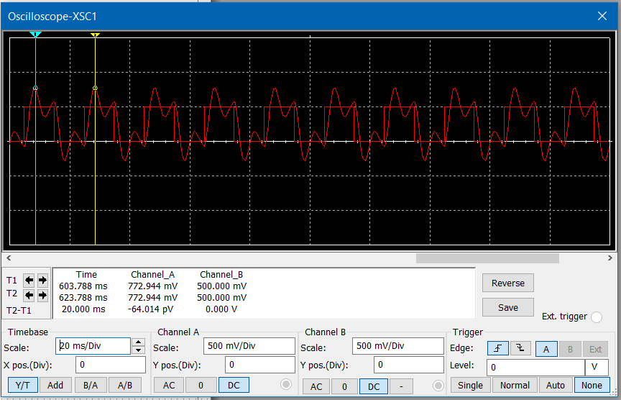

Figure 10. Oscilloscope reading of Figure 9's circuit

The last circuit shown above is when f=50Hz, which is below the resonant frequency. This oscillation is still a consistent pattern; however, the wave is not oscillating as a consistent sinusoid compared to the other two circuits. This circuit seems to be noisier and varies in terms of amplitude.

AC Sweep

The circuit shown below is set up with an AC Voltage source and differential voltage probes in order to obtain the Bode plot through Multisim’s AC Sweep.



Figure 11. RLC circuit with voltage probes

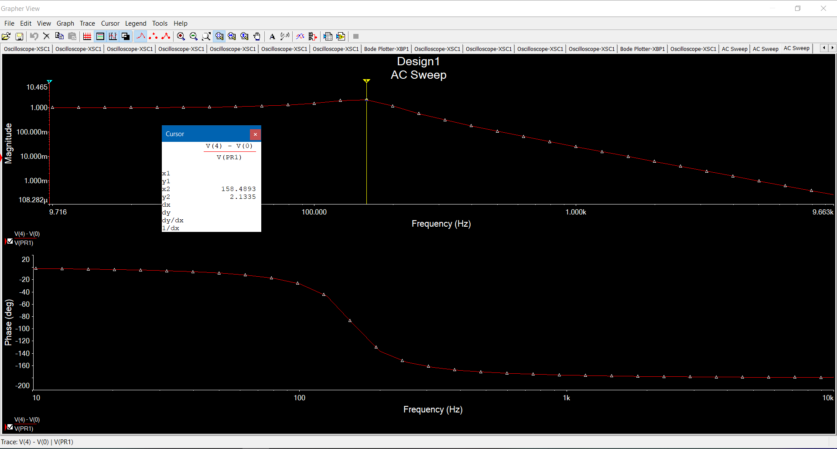

Figure 12. AC Sweep of RLC circuit with simulated Resonant Frequency

By setting the cursor to examine the Ymax, the peak frequency yields 158.4893 Hz, which using a simple percent difference calculator shows the calculated frequency vs simulated frequency to be within approximately 1.2% of each other.

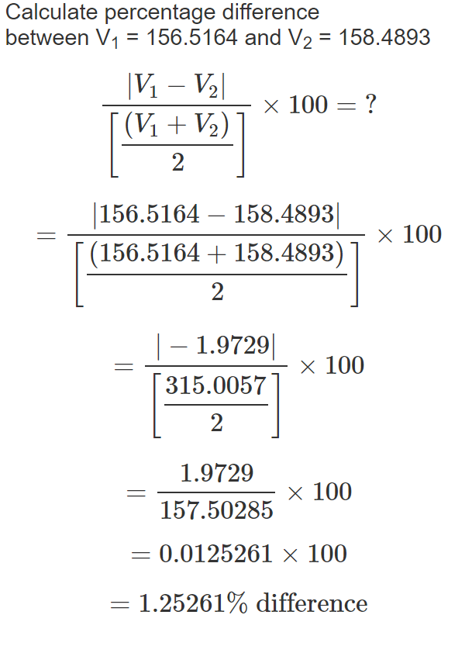

Figure 13. Percent Difference of Calculated and Experimental Resonant Frequency Values

Given the data collection, one might ask what are RLC circuits used for, and what is the effect of adding a resistor to an LC circuit?

RLC circuits are a kind of passive circuit that involves a resistor (R), inductor (L), and capacitor (C). LC circuits are harmonic oscillators that oscillate when energy shifts between the electrostatic field of a capacitor and magnetic field of an inductor. The effect of adding a resistor to an LC circuit is that it can control the rate of dampening the oscillation by slowing down or speeding up the rate at which current flows through the inductor and capacitor. The same effect can be accomplished by replacing the resistor with a potentiometer. An example of this is how oscillators work on musical synthesizers, by changing the potentiometer, it is manipulating the amount of resistance feeding into the circuit which will then change the rate at which the signal is oscillating, which then changes the frequency and pitch of what the oscillation sounds like. In addition to audio circuits, RLC filtering can also be used to filter other kinds of waves such as RF waves in microwaves, or Radio waves in transmitters. The RLC circuit may also be wired in series to be a voltage multiplier or in parallel to be a current multiplier. Since capacitors hold charge, an RLC circuit can function similarly to an RC circuit and be used to charge/discharge a circuit.

1. **Conclusion:**

This lab solidified using Multisim to model how RLC circuits behave. By creating an RLC series circuit and calculating the resonant frequency, I was able to examine how the resonant frequency will change the rate and amplitude at which a signal oscillates, with increasing the frequency allows a faster oscillation of a smaller amplitude, but decreasing the frequency allows a consistent underdamped signal to be outputted with larger amplitudes per period that decrease over time. When examining the frequency response of the circuit, the simulation resulted in a resonant frequency within a 1.2% difference of the calculated frequency. This lab served as an introduction to RLC circuits and the basis of RLC circuits may be used in a variety of applications as discussed earlier in the report ranging from audio oscillations/filtering to voltage/current multiplication.